**Apollo Passive Seismic Experiment Expanded Event Catalog**

**SUPPLEMENTAL ARCHIVE**

**Renee C. Weber1, Seiichi Nagihara2, and Jesse-Lee Dimech1**

**1NASA Marshall Space Flight Center, Huntsville AL**

**2Dept. of Geosciences, Texas Tech University, Lubbock TX**

This document contains information to explain the contents of the archive, which is submitted as a supplement to the integrated catalog of lunar seismic events that was delivered to the PDS, available here: <https://pds-geosciences.wustl.edu/missions/apollo/seismic_event_catalog.htm>. Our team integrated moonquake locations from the catalog into the GIS platform using ArcGlobe, an extension of ArcGIS[1]. Since ArcGIS is commercial software, these files are not compliant with PDS standards. However, as they were a named deliverable from the PDART award, we chose to archive them with the Lunar and Planetary Institute, so they would be available for use by the planetary community and broader public.

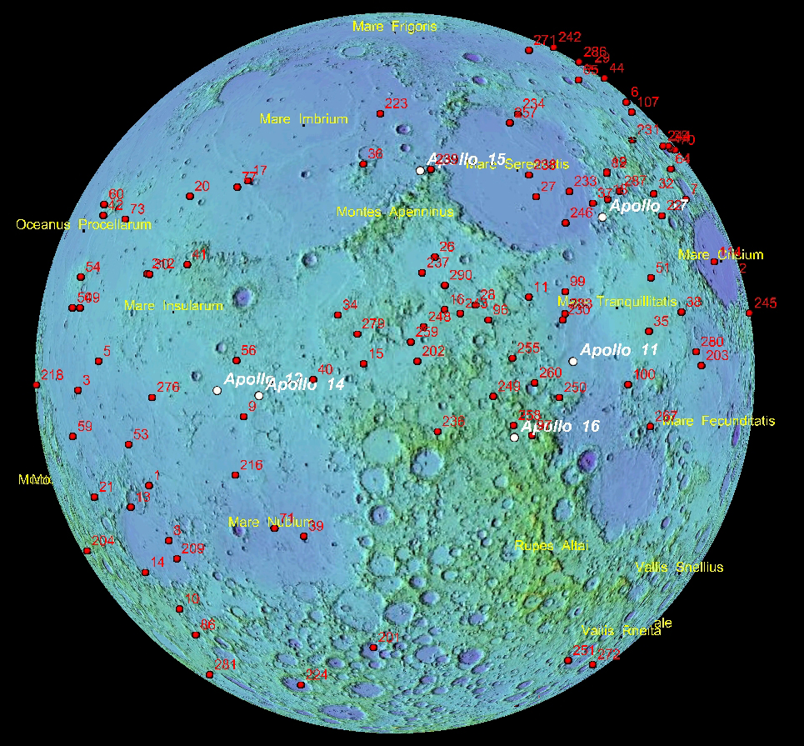ArcGIS software is widely available among universities in the United States, and compared to other ubiquitous global mapping software such as Google Earth/Moon, ArcGlobe is better suited for mapping features inside the globe (e.g., moonquake hypocenters) and it offers more tools for database queries. Even though ArcGlobe is designed for Earth, with simple scale corrections, it can be used to map features on and inside the Moon (Fig. 1). ArcGlobe belongs to a family of ESRI GIS software products called ArcGIS Desktop, and the United States Geological Survey (USGS) Astrogeology Center has been releasing lunar data products that are compatible with ArcGIS. Therefore, using ArcGlobe, the moonquake data can be easily compared and cross- referenced with other available lunar data.

Figure 1: The near side of the Moon with the epicentral locations of moonquake clusters (Nakamura, 2005), plotted on the topographic relief map generated by USGS (data from the Lunar Orbiter Laser Altimeter onboard the Lunar Reconnaissance Orbiter), as displayed on ArcGlobe. The red labels show the ID numbers assigned to the clusters. The white dots indicate the Apollo landing sites.

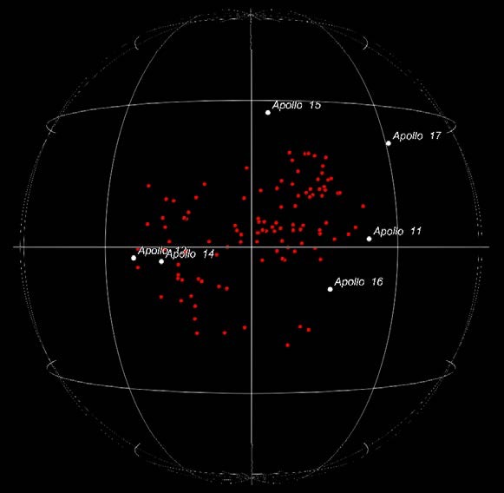Figure 2 shows the hypocenteral locations of the deep moonquake clusters without the surface relief. All the maps in Figures 1 and 2 can be made from one set of 3-D work environments on ArcGlobe with ease.

Figure 2a. A 3-D plot of the hypocentral locations of the deep moonquake clusters.

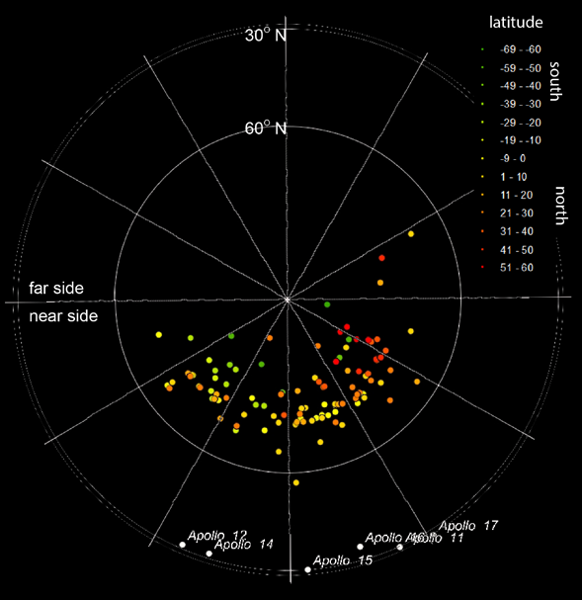

Figure 2b. A 3-D hypocenter plot of the same clusters in a north-polar projection. The dots are color-coded by their latitudes. The red and orange dots are in the northern hemisphere and the green and yellow dots are in the southern hemisphere.

**Use of GIS in analytical work**

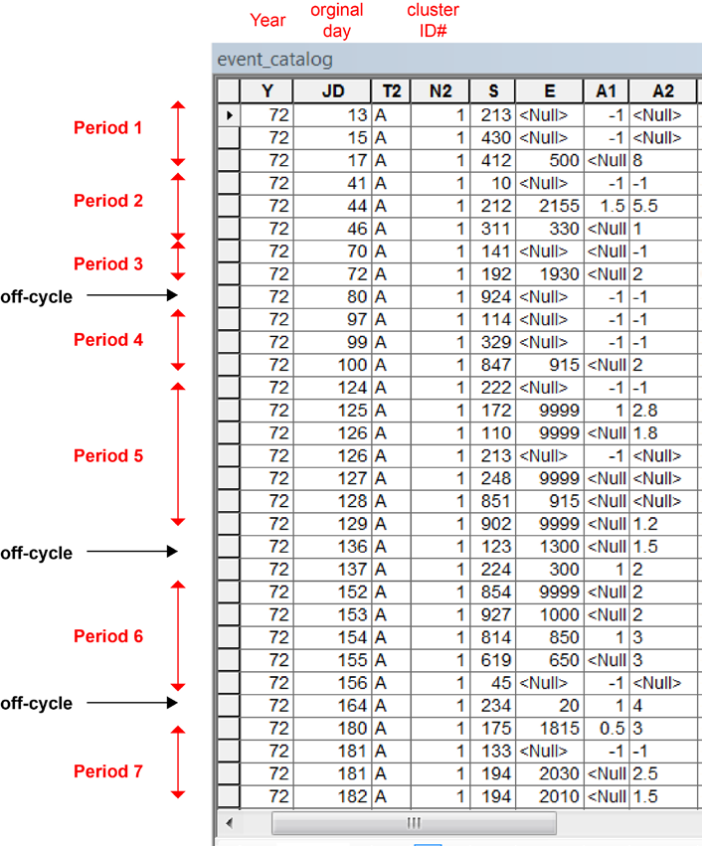Beyond the 3-D visualization, ArcGlobe can be used for temporal and spatial analysis of the moonquake data. Figure 3 shows a screen shot of the event catalog imported into the ArcGlobe working environment. This particular example has been filtered to show only the events originating from cluster A1. The A1 events have been known to occur with ~27-Earth-day cycles (Bulow et al., 2007). Many other deep moonquake clusters become active with similar periods. Therefore, deep moonquake activities are linked to the tidal stress (e.g., Weber et al., 2009). The A1 events listed in Figure 3 are from the first 6 months of 1972. In each lunation period, the cluster triggers 2 or more moonquakes over 2 to 6 Earth days. However, there are some moonquakes that are off the 27-earth-day recurrence cycle. The event in ordinal day 80 is such an example. There were two more such occasions during the first half of 1972.

Figure 3. A screen shot of the event list for cluster A for the first half of 1972. The events that occurred in sync with the lunation periods are shown with red arrows. The events that are off-cycle are indicated by black arrows.

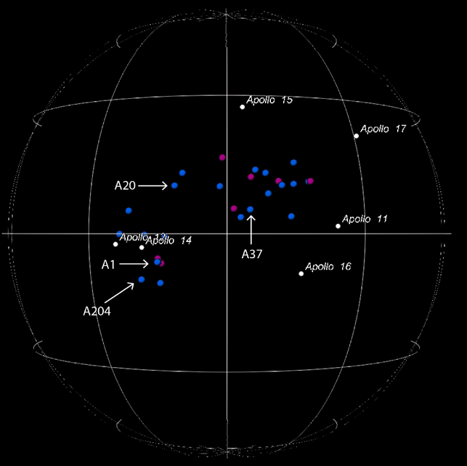During the periods when A1 was active, several other clusters were active as well. Figure 4a shows all the events detected during Period 1 (Days 13-17) and Period 2 (Days 41-46) in the near-side view. Four of these clusters (A1, A20, A37, and A204) were active for both of these periods. Figure 4b shows the same clusters viewed through the western hemisphere. The clusters that were active in these periods seem to form two mega-clusters.

Figure 4a. The hypocenters of the deep moonquakes that occurred in Periods 1 (day 13-17, blue) and 2 (day 41-46, magenta) in Figure 3. Viewed through the near side.

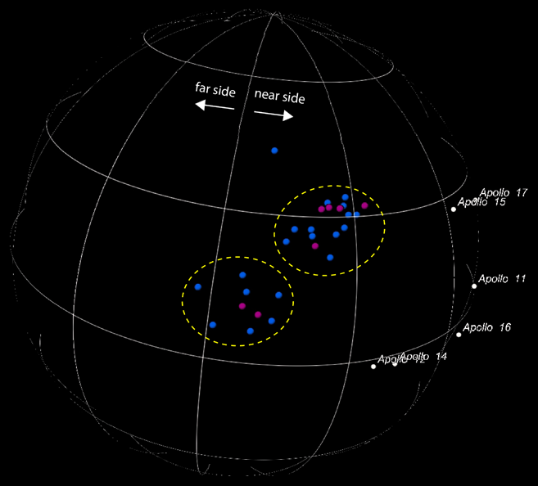

Figure 4b. The same moonquake clusters viewed through the western hemisphere. It is more obvious in this view that the clusters form two mega-clusters.

Figure 5a shows the clusters that were active on Day 80 and Days 136-137 in the near-side view. These were the times when A1 triggered moonquakes out of sync with its lunation cycle. The off-cycle events consist mainly of clusters that were not active in Periods 1 and 2, except for A20. In other words, A20 seems active whenever A1 is active. However, A1 and A20 are not particularly close to each other.

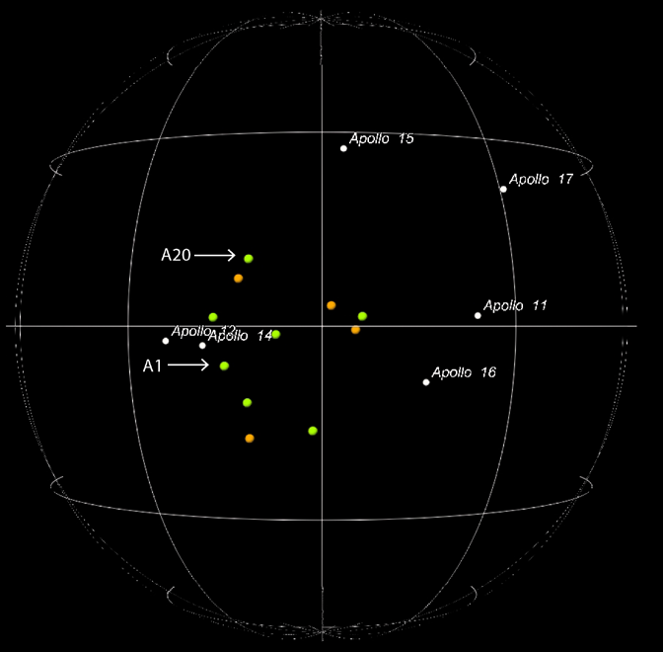Figure 5b compares the locations of the clusters from Figure 4 with the off-cycle clusters. This plot is also seen through the western hemisphere. Except for A20, these two sets of clusters do not overlap much in their spatial distribution. The off-cycle events (orange and green in Figure 5b) are more sparsely distributed but seem to occur between the two mega-clusters identified Figure 4b.

Figure 5a. The clusters that were active on Day 80 (orange) and Days 136-137 (green). Viewed through the near side.

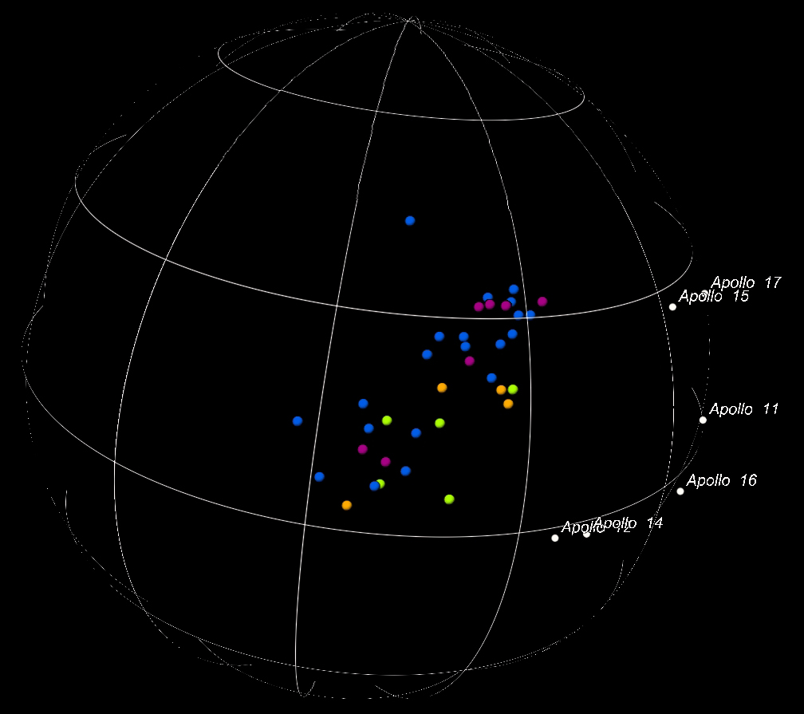

Figure 5b. The same clusters plotted with those from Figure 4b. Viewed through the western hemisphere. The off-cycle clusters (orange and green) seem to occur in the gap between the two mega- clusters (blue and magenta).

While it is not the intention of this effort to look further into the analysis of the spatial and temporal distribution of these moonquakes, but this example demonstrates the great potential for the use of GIS in analytical work.

**References**

Bulow, R. C., Johnson, C. L., Bills, B. G., & Shearer, P. M. (2007). Temporal and spatial properties of some deep moonquake clusters. Journal of Geophysical Research, 112(E9). <https://doi.org/10.1029/2006JE002847>.

Nakamura, Y. (2005). Farside deep moonquakes and deep interior of the Moon. Journal of Geophysical Research, 110(E1). <https://doi.org/10.1029/2004JE002332>.

Weber, R. C., Bills, B. G., & Johnson, C. L. (2009). Constraints on deep moonquake focal mechanisms through analyses of tidal stress. Journal of Geophysical Research: Planets, 114(E5). <https://doi.org/10.1029/2008JE003286>.

1. <https://desktop.arcgis.com/en/arcmap/latest/extensions/arcglobe/the-arcglobe-user-interface.htm>